44.24: a) Using the values of the constants from Appendix F,
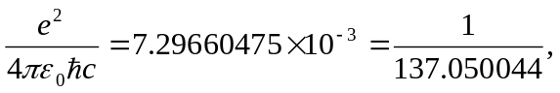
or 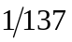to three figures.
b) From Section 38.5
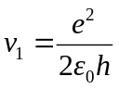
but notice this is just 